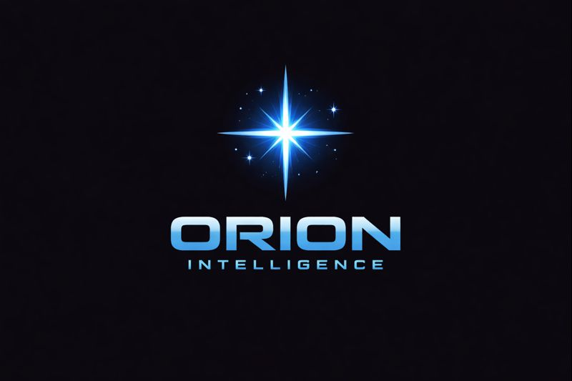

Technical Architecture: Metis Persistent Memory Extension for Antigravity

Author: Dimitris (Orion Intelligence)

Date: March 17, 2026

1. Executive Summary Metis is a native Antigravity extension designed to solve the "context window" limitations of LLM agents. By implementing a local Retrieval-Augmented Generation (RAG) layer, Metis allows agents to persist knowledge across sessions with sub-15ms latency and zero API costs for embeddings.
2. Core Architecture The system operates on a three-tier architecture:
- Storage Layer: Uses ChromaDB as a local vector database. This ensures 100% data privacy as no sensitive code or logs leave the user's machine.
- Embedding Engine: Utilizes the all-MiniLM-L6-v2 model via sentence-transformers. This allows for high-quality semantic mapping entirely on the local CPU/GPU.
- Integration Layer (The Extension): A manifest.json and extension_entry.py hook into the Antigravity lifecycle (on_session_start and provide_context).
3. Performance Benchmarks During internal testing at Orion Intelligence, Metis achieved the following results:
- Average Retrieval Latency: 14.83 ms.
- Optimization: Hierarchical Navigable Small World (HNSW) indexing with Cosine similarity.
- Context Efficiency: Adaptive top-k retrieval based on query language, reducing processing overhead by ~20% for English queries.
4. How the "Hook" Works When a user starts a session, the extension automatically:
- Scans the local orion_memory directory.
- Indexes new file changes or session logs.
- Injects relevant historical context into the System Prompt before the first LLM interaction.

